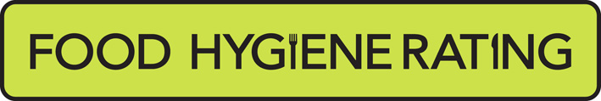  Food Hygiene Rating Scheme: Appeal form |  | 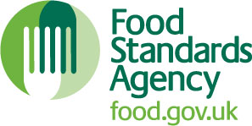

Notes for businesses:

- As the food business operator of the establishment you have a right, under Section 3 of the Food Hygiene Rating Act (Northern Ireland) 2016, to appeal the food hygiene rating given following your inspection if you do not agree that the rating reflects the hygiene standards found at the establishment at the time of the inspection.
- You have 21 days (including weekends and bank holidays) from the date of receipt of the notification letter to lodge an appeal.
- Please use the form below and return it to your district council – contact details are provided with the written notification of your food hygiene rating.
- Your appeal will be determined by an authorised officer and the outcome of your appeal communicated to you within 21 days from the date the appeal was received.

Business details

Food business operator/proprietor

Business name

Business addresses

Business tel. number |  | Business email

Inspection details

Date of inspection |  |  |  |  |  |  |  | Food hygiene rating given
Date notified of rating
Appeal

I do not agree with the food hygiene rating given by the food safety officer because (please explain below under each of the three headings).

Compliance with food hygiene and safety procedures

Compliance with structural requirements

Confidence in management/control procedures

Signature
Name in capitals

Position |  | Date

Please now return this form to mailto:food@midandeastantrim.gov.uk or post to

Environmental Health, Environmental Health Environmental Health
Ardeevin, Museum and Civic Centre Smiley Buildings
80 Galgorm Road, 11 Antrim Street Victoria Street
Ballymena, BT42 1AB Carrickfergus BT38 7DG Larne BT40 1RU

