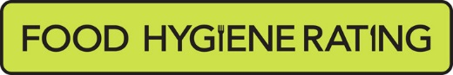  Food Hygiene Rating Scheme: Request for a re-rating inspection |  | 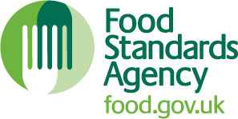

Notes for businesses:
- As the food business operator of the establishment you have a right to request at any time a visit for the purposes of re-rating under section 4 of the Food Hygiene Rating Act (Northern Ireland) 2016 provided that you have paid the £ 150 cost of the re-rating inspection in accordance with section 4(7) of The Food Hygiene Rating Act (Northern Ireland) 2016 and the following conditions are met:-
- You must wait until the end of the 21 days appeal period before you apply for a re-rating inspection
- Any appeal against the current food hygiene rating has been determined or abandoned:
- You must provide details of the improvements made to hygiene standards with your request, including supporting evidence where appropriate.
- The district council considers that you have provided sufficient evidence that the required improvements have been made.
- You must also be compliant with the Act. This means that you must display your current valid rating sticker. A re-rating inspection will not be carried out if you are found to be non-compliant and a £200 fixed penalty notice may be served for non-compliance.
- The district council officer will give you a ‘new’ food hygiene rating based on the level of compliance that is found at the time of the re-visit - you should be aware that your rating could go up, down or remain the same.
- The re-rating visit will take place within 3 months of the request being made and will usually be made without prior notification.

Business details
Food business operator/proprietor

Business name

Business addresses

Business tel. number |  | Business email

Inspection details
Date of inspection |  |  |  |  | Food hygiene rating given

Action taken
Please describe the remedial action you have taken with reference to the issues identified in the inspection letter/report provided to you by your district council with your score:
Compliance with food hygiene and safety procedures

Compliance with structural requirements

Confidence in management/control procedures

Please provide any other supplementary evidence (e.g. photographs, invoices, copies of relevant HACCP documentation etc.).

Signature
Name in capitals

Position |  | Date

Please now return this form and payment of £150 to your local Environmental Health Office below Cheques should be made payable to Mid and East Antrim Borough Council.
Environmental Health, Environmental Health Environmental Health
Ardeevin, Museum and Civic Centre Smiley Buildings
80 Galgorm Road, 11 Antrim Street Victoria Road
Ballymena, BT42 1AB Carrickfergus BT38 7DG Larne BT40 1RU

